***Output for the code virtual key repository***

1. This is the first output when the code is ran

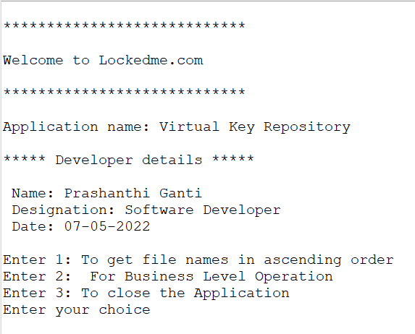

1. When user select the 1st option the files in the mentioned folder will be appear in the sorted manner/ascending order

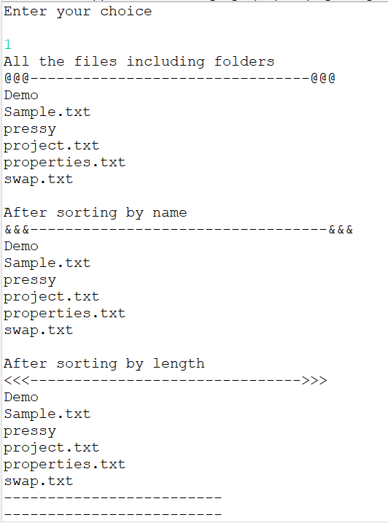

Below are the actual files present in the folder

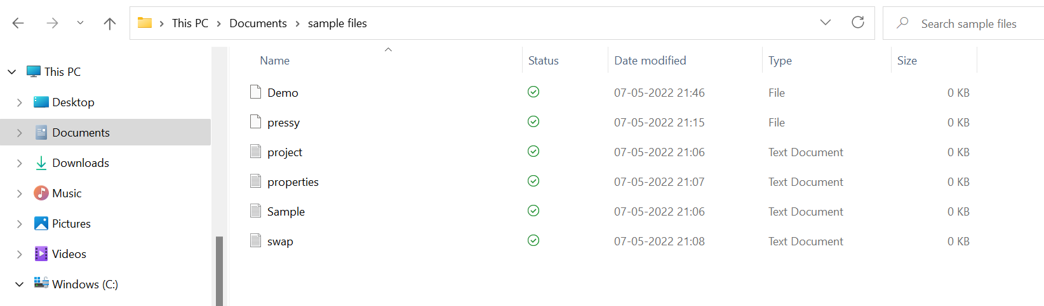

1. When user opted for 1st option under Business level operations the below output will be printed

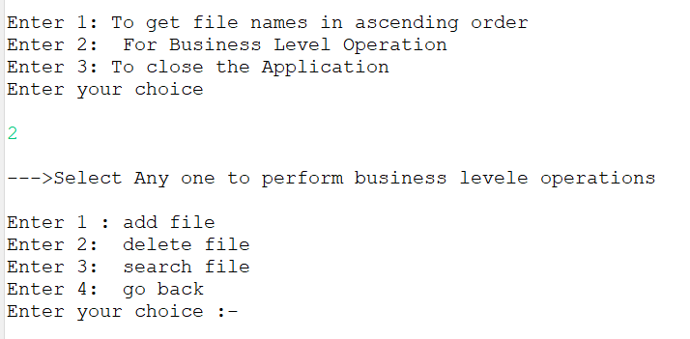

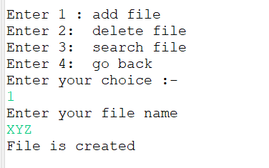

We can see the “XYZ” file is created

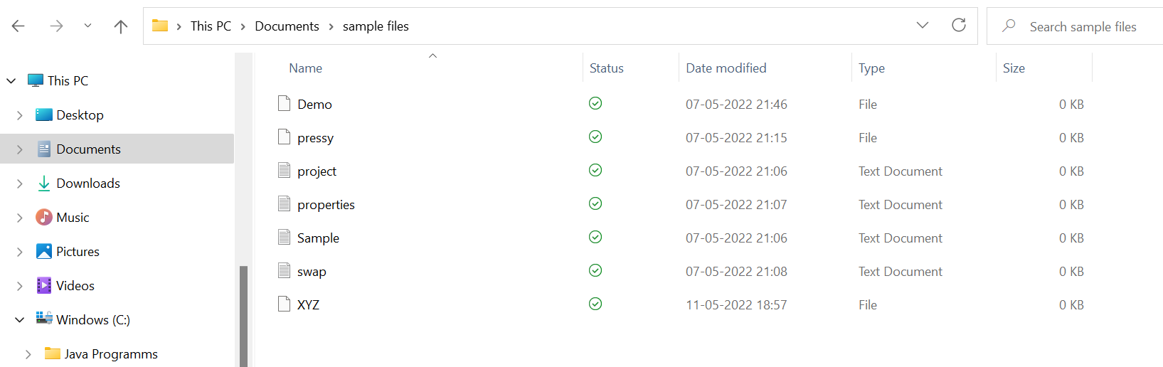

1. When user opted for 2nd option under Business level operations mentioned file will be deleted as follows

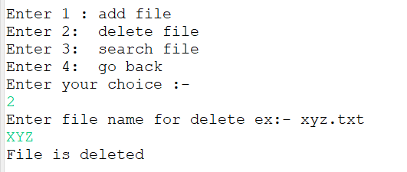

We can see file is deleted from the folder

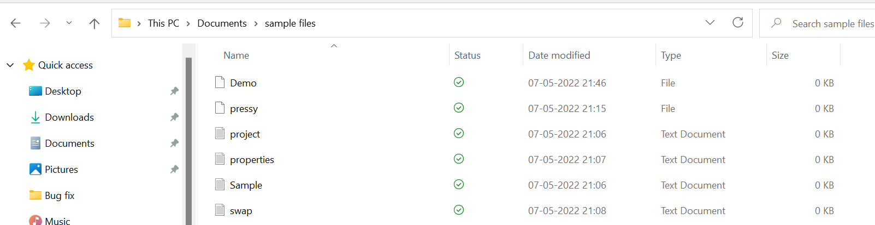

1. When user opted for 3rd option under Business level operations it will display to enter a file name to search as below snap

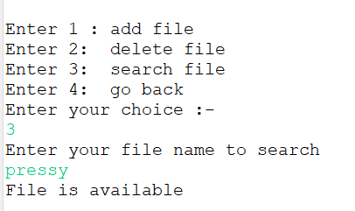

When mentioned file is not there it will display the below message as Dolly file is not present in the folder

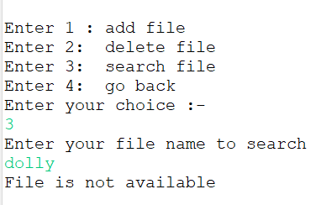

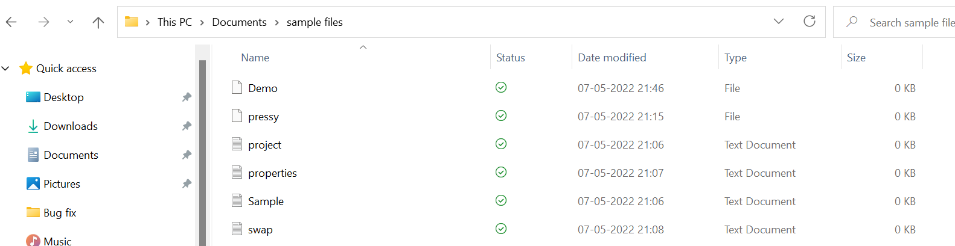

1. When user opted for 4th option under Business level operations it will display the below message.

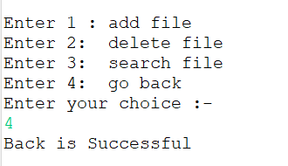

1. When user Enter the 3rd option it will close the application and gives the message “Exit”

